**MINAHIL QADIR**

**BSAI-3A(047)**

**TASK 6:**

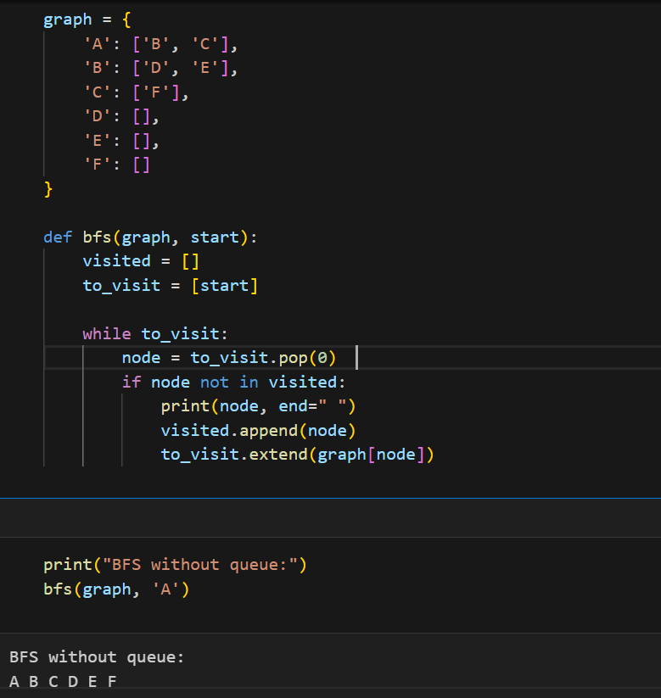

This program performs Breadth-First Search (BFS) on a graph.

The graph is stored as a dictionary where each node has a list of connected nodes.

bfs(graph, start) starts traversal from a given node.

A queue (to_visit) is used to keep track of nodes to visit next.

Steps of BFS traversal:

Remove the first node from the queue.

If it hasn't been visited, print it and mark it as visited.

Add its neighbors to the queue.

Nodes are visited level by level (FIFO approach).

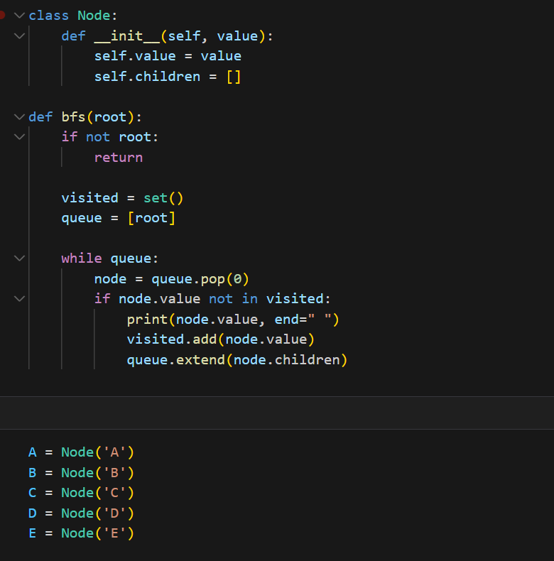

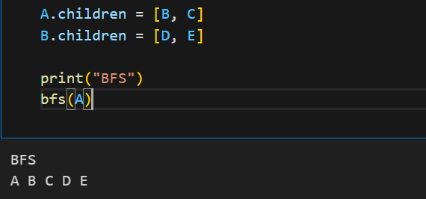

This program searches a tree level by level using Breadth-First Search (BFS).

Each node has a value and children.

A tree is created with A as the root, B and C as children, and D and E under B.

BFS starts from A, visiting nodes in order:

Uses a queue to track nodes to visit.

Prints each node and adds its children to the queue.

Nodes are printed in BFS order: A B C D E.